**Washoe County School District**

**SB 467 Zoom Schools Annual Report**

**Program and Services**

**School Year 2019-2020**

**December 18, 2020**

#### TABLE OF CONTENTS

Executive Summary 1

Introduction 8

Pre-Kindergarten (Pre-K) 10

Reading Skills Centers 11

MAP Reading Assessment Results – Elementary 15

Smarter Balanced Assessment Consortium (SBAC) 21

SBAC – ELA Zoom Elementary 21

ACCESS Exit Rates for EL - Elementary 23

Nevada Growth Model – EL AGP Performance – Elementary 24

Zoom Extended Day Model for Grades K-3 26

Zoom Middle Schools 30

SBAC – ELA Zoom Middle Schools 33

ACCESS Exit Rates for EL – Middle Schools 34

Nevada Growth Model – EL AGP Performance – Middle Schools 35

Corrective Action Schools 37

Professional Development 37

Recommendations from Washoe County School District 39

**Report Prepared by:**

Karen Perisho, Zoom School Coordinator

Norma Velasquez-Bryant, PhD, Program Evaluator, Accountability

Kimberly Lynch, Grant Accountant

Lauren Ohlin, Director of Grants

# Executive Summary

In 2013, the Nevada Legislature enacted Senate Bill 504 aimed at improving the academic performance of English Learners. SB 504 specifically states, *“It is the intent of the Legislature that children who are limited English proficient be provided with services and instruction which is designed to address the academic needs of such children so that those children attain proficiency in the English language and improve their overall academic and linguistic achievement and proficiency.”* (NRS 388.405). By way of SB 504, the Nevada Department of Education (NDE) allocated money to school districts to provide specific programs and services to the lowest performing schools with the highest percentage of English Learners. These schools are known as Zoom schools, and SB 504 has continued through successive legislative cycles. The continuation of funding has allowed Nevada school districts to sustain programming and services implemented in an effort to continue to improve the academic and language achievement of English Learners.

The 2019 Nevada legislature enacted SB 467, providing funding to Washoe County School District (WCSD) to maintain 24 Zoom schools - 19 District elementary schools, one District-sponsored charter elementary school, and four District middle schools. WCSD Zoom schools served 11,273 students, with 4,115 (36.5%) identified as EL in School Year (SY) 2019-20.

In accordance with the requirements of the law, WCSD continued the implementation of a variety of programs and services aimed at helping to improve the academic and language achievement of English Learners. The main programs included:

*Pre-K Programs*: Early instruction and intervention is crucial to a child’s development, including their language and academic achievement. In alignment with the state performance goal to “Increase the percentage of students who enter kindergarten ready to succeed…” WCSD has continued to offer pre-K services across the District. During SY 2019-20, WCSD provided Pre-K programming to an average of 805 students across the District, with an average of 325 (40.4%) of those students attending Pre-K at Zoom schools.

*Reading Skill Centers*: Access to high-quality, grade level instruction can help to accelerate both academic and linguistic achievement. Through the embedded Reading Skills Center design in WCSD, students are engaged in high-quality, Tier 1 instruction that also focuses on increasing language proficiency. At the elementary level, Reading Skills Centers engage students in daily, small group language and literacy instruction. In the middle schools, additional staff were hired to reduce class sizes to provide smaller group instruction in literacy and language.

*Extended Day Program, K-5*: Sixteen of the Zoom elementary schools (N=20) utilized the 21st CCLC/TEAM UP TEAM UP academic hour for their extended day programming in SY 2019-20. The remaining four schools that did not have TEAM UP used Zoom funding to provide extended learning time outside of the normal school day. Each school designed programs to meet their unique needs.

*Middle School Extended Day*: Vaughn and Sparks middle schools used the 21st CCLC/TEAM UP TEAM UP academic hour for extended day programming in SY 2019-20. Traner and Dilworth middle schools used Zoom funding to provide extended learning time for students. Each of these schools designed a

unique program to meet their needs. Sparks Middle School also intended to offer a summer jump start program to incoming 6th graders, but due to COVID-19, the program was cancelled.

In conjunction with these main programs, WCSD has continued to include teacher professional learning (PL) and collaboration as part of the Zoom plan. A variety of opportunities provided teachers with learning and critical professional collaboration that allowed them to explore the link between language and learning, plan for high-quality language and content-based instruction, and continue to improve the fidelity of implementation of programs that best served the students in WCSD.

Due to COVID-19, many of the annual assessments were cancelled. However, WCSD was still able to capture some student achievement data, including the English Language Proficiency Assessment (ELPA). A summary of each assessment that took place prior to COVID-19 and the corresponding results are as follows:

Brigance Early Childhood III Screens were used in the Pre-K program to screen students for readiness for learning: “Ready to Learn” ≥60th percentile. During the Fall 2018 - Spring 2019, approximately 538 Pre-K students were screened with an Average Score-Pre of 84, and an Average Score-Post of 88. All students met the Ready to Learn threshold. Data are not available for SY 2019-20.

During SY 2016-17, Zoom schools received funding to implement Pre-K programs. Students who attended the Zoom Pre-K programs during this time have been grouped as a cohort and various data are being monitored to assess student performance through Grade 3 in SY 2021. These will include MAP Growth Reading, ACCESS Exit Rates, and SBAC-ELA levels. Four Pre-K cohorts have been defined as follows for future comparison: The number of students who were designated as an EL in Grades 1-2 that attended Zoom Pre-K in SY2016-17 (N=550): SY 2018-19 Grade 1=36 (7%); SY 2019-20 Grade 2=34 (6%); the number of students who were designated as an EL in Grades 1-2 that DID NOT attend a Zoom Pre-K in SY 2016-17 (N=331), but attended another Title I, non-Zoom school: SY 2018-19 Grade 1=21 (6%); SY 2019-20 Grade 2=18 (5%); the number of students who were designated as an EL in Grades 1-2 that attended an external Pre-K program (non-District program) in SY 2016-17 (N=210): SY 2018-19 Grade 1=16 (8%); SY 2019-20 Grade 2=154 (73%); and the number of students who were designated as an EL in Grades 1-2 that did not attend a Pre-K in SY 2016-17 (note: attendance data were not reported): SY 2018-19 Grade 1=602; SY 2019-20 Grade 2=593.

Beginning in SY 2018-19, NDE mandated that kindergarten programs use the Brigance Early Childhood Screens III, with the fall assessment used for placement purposes only. Nevada State Regulations also mandated MAP Growth Reading assessments for kindergarten during Winter and Spring testing sessions. The MAP Growth Reading-ELA Proficiency level is defined as >40th percentile.

**NOTE: Results presented in this report reflect SY 2018-19 due to the transition to distance learning and suspension of end-of-year assessment testing for SY 2019-20. Where possible, results are presented for Winter 2019 assessments for SY 2019-20. The ELPA was administered prior to the transition to distance learning and reflect SY 2019-20 results.**

For SY 2018-19, kindergarten results show that 16% (3 schools) had less than 20% of students that met proficiency; 11% (two schools) had 20-29% of students that met proficiency; 32% (six schools) had 30-39% of students that met proficiency; 26% (five schools) had 40-49% of students that met proficiency; 5% (one school) had 50-59% of students that met proficiency; 11% (two schools) had 60-69% of students that met proficiency; and, collectively, Zoom schools had an average of 37% of kindergarten students that met proficiency compared to the overall District at 55%. Additionally, a comparison of kindergarten EL students vs. Non-EL students at Zoom schools, other Title I Non-Zoom schools, and WCSD indicate that EL kindergarten students are performing at approximately the same level as other Title I schools, and slightly less, 6.4%, than EL kindergarten students in the rest of the District.

Spring 2019 MAP Growth Reading for Grade 1 results show schools that met the 40th Percentile Proficiency - as follows: 5% (one school) had less than 20% of students that met proficiency; 21% (four schools) had 20-29% of students that met proficiency; 32% (six schools) had 30-39% of students that met proficiency; 26% (five schools) had 40-49% of students that met proficiency; 16% (three schools) had 50-59% of students that met proficiency; and Overall Zoom schools had an average of 37% of Grade 1 students that met reading proficiency compared to the Overall District at 54%. A comparison of EL students vs. Non-EL students in Grade 1 at Zoom schools, other Title I Non-Zoom schools, and WCSD indicate that EL Grade 1 students are performing slightly less (-1.8%) than other Title I schools, and less than (-7.1%) EL Grade 1 students in the rest of the District.

Spring 2019 MAP Growth Reading for Grade 2 results show schools that met the 40th Percentile Proficiency - as follows: 0% (0 schools) had less than 20% of students that met proficiency; 11% (two schools) had 20-29% of students that met proficiency; 32% (six schools) had 30-39% of students that met proficiency; 47% (nine schools) had 40-49% of students that met proficiency; 11% (two schools) had 50-59% of students that met proficiency; and Overall Zoom schools had an average of 41% of Grade 2 students that met proficiency compared to the Overall District at 55%. A comparison of EL students vs. Non-EL students in Grade 2 at Zoom schools, other Title I Non-Zoom schools, and WCSD indicate that EL Grade 2 students are performing slightly better (+1.3%) than other Title I schools, and less than (-5.2%) EL Grade 2 students in the rest of the District.

Winter 2019 MAP Growth Reading for kindergarten results show that only 32.3% of students in Zoom schools met >40th percentile proficiency.

Grade 3 students were assessed using the SBAC-ELA. Results for Zoom school students showed no change in proficiency (met AL Level 3 and 4), at 27% for both SY 2017-18 and SY 2018-19, with a slight increase (+3.0%) from SY 2016-17. Overall Zoom students had lower proficiency rates than similar Title I non-Zoom schools who experienced a slight decrease in Grade 3 proficiency from 2018 to 2019 (33% to 32%, respectively). Overall, students in WCSD decreased slightly from 45% to 44%, respectively, for SY 2017-18 and SY 2018-19. In Grade 3, there was no change for non-EL students - 27% each year; and a decrease for EL students, from 17% to 14%.

Grade 8 students were also assessed using the SBAC-ELA. Results for Zoom school students showed and increase for non-EL students - 32% to 35%, SY 2017-18 to SY 2018-19, respectively; and no change for EL students at 5% each year.

The ACCESS (Assessing Comprehension and Communication in English State-to-State for English Learners) is an annual summative assessment of the developing social and academic English language proficiency for EL students in kindergarten through 12th grade.

Results indicate WCSD Zoom elementary schools showed a slight increase of 0.8% in the total number of students exited between SY 2018-19 and SY 2019-20, from 11.8% to 12.5%. Zoom school students also exited at a slightly higher rate than similar Title I non-Zoom schools in SY 2019-20 - 12.5% versus 11.0%, respectively. The overall exit rates for WCSD elementary schools show an increase between SY 2018-19 and SY 2019-20, from 10.8% to 13.0%, and an increase of 0.5% compared to Zoom schools. WCSD is also 2.0% higher than similar Title I non-Zoom schools, 13.0% vs. 11.0%, respectively.

Results indicate that WCSD Zoom middle schools showed a decrease of 2.1% in the total number of students exited between SY 2018-19 and SY 2019-20, from 6.7% to 4.6%. Additionally, Zoom middle schools exited at a higher rate than similar Title I non-Zoom schools did in SY 2019-20, 4.6% versus 3.0%. The results for WCSD middle schools overall show a decrease of 2.2% between SY 2018-19 and SY 2019-20.

The Nevada Growth Model (NGM) measures student growth on state assessments compared to other students in the state with a similar score history. The Adequate Growth Percentile (AGP) on the ACCESS test is the Student Growth Percentile (SGP) an EL student needs to stay on track to reach a proficient level within five years or by grade 10. NDE has established recommended performance levels and outcome indicators for Zoom funded schools. It is important to note that the AGP is only one of several measures used to evaluate progress of EL students in the state. NDE recommended the AGP performance target for Zoom schools be set at the 50th percentile for all elementary schools with sufficient N-count of EL students (adopted by SBE in June 2016).

Results from WCSD Zoom middle schools, SY 2019-20, percentage of EL students who met WIDA AGP, show that three Zoom middle schools showed a slight decline in AGP between SY 2018-19 and SY 2019-20, and one middle school remained flat.

The NSPF consists of a Star Rating based on various metrics, one of which is AGP. A comparison of star ratings for Zoom elementary schools between SY 2017-18 and SY 2018-19 show that seven (35%) schools increased their rating, 11 schools (55%) maintained the same rating, and only two (10%) schools decreased by one star. A comparison of star ratings for Zoom middle schools between SY 2017-18 and SY 2018-19 show two schools maintaining their rating, and two schools increasing their star rating by one star.

**Impact of COVID-19**

The COVID-19 pandemic had a significant impact on Zoom schools during the spring of SY 2019-20. After spring break, all schools abruptly transitioned to distance learning due to the stay-at-home order issued by Governor Sisolak. Without an adequate number of devices for students and the lack of connectivity for many families, WCSD distance learning was available to students through a paper packet form, online assignments, or a combination of both.

During this time of distance learning, academic learning was solely focused on review of content taught prior to spring break. This decision was made based on the fact that WCSD did not have the adequate resources to ensure that all students could access online learning. Without access to online instruction, students would not be able to receive the new content instruction for those standards that would have been taught in 4th quarter. Language instruction and support was also a challenge during this time. While teachers did offer online assistance to students and families through office hours, class meetings, etc., not all students were able to participate due to a technology void. For those families who were not able to check in online, school staff reached out via the phone to check in and offer assistance. Despite these efforts, some students and families were not connected with school during the entire 4th quarter.

Academic assessments, both local and state, were not given during 4th quarter. This lack of data made it hard to gauge student proficiency on standards moving into the next grade level. It also made it difficult to analyze the success and challenges of various programs and initiatives across the District.

During distance learning, the entire District worked tirelessly to adapt to the new normal and to help ensure students had what they needed to be successful. School site staff continued to work with students remotely; Nutrition Services offered meal services through a pickup program; Central Office staff, teams of administrators, and teachers worked together to continue to build the distance learning assignments; Transportation worked to delivery packets and meals; IT and school sites worked to check out devices to students; and the entire WCSD team worked to keep students and families engaged. However, despite these supports, many students still struggled during this time of distance learning.

**Conclusions**

There is still a critical need for continued focus on the progress and achievement of EL students in WCSD. To this end, WCSD will continue to focus on high-quality, grade-level Tier 1 instruction that includes intentional language learning strategies and supports. Evidence-based interventions will continue to be used to accelerate the growth of students that are not at grade-level, and professional learning will continue to be implemented to build the capacity of all educators in WCSD around the language and content needs of ELs. WCSD will continue to incorporate best practices for both in-person and distance learning, with a focus on teacher professional development in these areas as well student engagement in all learning models.

**Recommendations:**

The Zoom School initiative has enabled WCSD to reconsider and restructure thinking and practice regarding the appropriation of new models for growth and modes of teaching and learning to support EL students. The major investments must focus on strengthening the collective capacity of teachers, school administrators, and district leaders to create conditions for improved instructional practice and student achievement.

WCSD Zoom schools will maintain uninterrupted programming and services as a result of legislators’ decision to continue Zoom funding for the next biennium, 2021-2023. The program impact will allow sustained support through SY 2021-22 and SY 2022-23 for all 24 Zoom schools. Zoom funding will provide WCSD the resources and opportunity to continue critical programming.

WCSD recommends continued funding for the following:

1. Certified teachers and classified staff to reduce class size and provide students with the high-quality, targeted EL and literacy instruction they need.
2. Professional learning for teachers to ensure that EL, literacy, and intervention instruction is delivered to the highest degree possible.
3. Intersession and/or extended day programs to provide students additional instructional time outside of the regular school day and to continue work with existing afterschool programs such as 21st CCLC/TEAM UP Community Learning Centers to maximize efficiency (teachers’ availability) and not compete with other after school programs to ensure student attendance.
4. Pre-K programs to strengthen kindergarten readiness.
5. Critical resources to enhance EL, literacy, and intervention instruction and programs (e.g. Reading Skills Centers, ELLevation).

WCSD recommends the elimination of the 5%spending cap. This would allow all Zoom-funded LEAs the flexibility and ability to better support schools through high-quality teacher professional development opportunities. LEAs would also be able to explore potential strategy development of effective teacher recruitment and retention incentives, and potential increases in family engagement activities leading to successful language acquisition growth for all Zoom school students.

WCSD has a significant concern around the timing of grant funding availability. While it is understood that funding must wait on legislative timelines, this makes planning difficult.

* Schools often lose highly qualified individuals from their staff at the end of a grant cycle due to the overage of the grant funded position and the next cycle of funding not being available to renew the position in time to guarantee the individual a job for the upcoming year.
* Districts are often waiting on initial budgets to be approved until late fall which makes it difficult to hire new individuals and purchase necessary items to support instruction and student achievement in the first quarter or so of school.
* Budget revision requests are often delayed at NDE for four to eight weeks, again delaying schools’ opportunity to spend money on current needs. This delay has even resulted in schools missing important professional learning opportunities.
* The funding timeline overall delays services to students and ultimately results in schools and districts not being able to spend funds in a timely or fully executed manner.

WCSD recommends that NDE work to expedite the timeline for budget approvals and revision requests. Another recommendation is to create a pre-approval process where districts could outline the intent for funding in the spring and obtain pre-approval on items that could then quickly be approved once final budget numbers are awarded.

WCSD would also like to share some concerns regarding the new weighted funding formula:

* The current level of weighted funding per student is inadequate.
* There may need to be legislative cleanup of current statutes and regulations to better align with the new Pupil-Centered Funding Plan’s requirements.
* The current weighted funding for EL, as recommended by the Commission on School Funding, provides one tier (i.e., one weight), which does not account for the different levels of aptitude and levels of service required for the multiple categories of EL students. There may need to be clarifying language in statute or regulations to allow school districts to provide differing levels of service, versus a one-size-fits-all approach based on one weight.
* There is no funding provided for the follow-up of EL students that have graduated out of EL instruction. These students are not counted in the tabulation of EL students for which the District will receive funding under the new Pupil-Centered Funding Plan. However, school districts are required by federal law to monitor exited students for four years and this increases the case load of EL teachers.

# Introduction – WCSD Zoom School Programming

SB 467 funds supported programming in 24 schools (20 elementary and four middle schools) during SY 2019-20 to implement key initiatives mandated by the Nevada Legislature. These included:

1. Pre-K Program - critical early literacy skill development.
2. Reading Skills Centers - daily responsive small group literacy instruction.
3. Extended Day Program - additional instruction beyond the school day.

Additionally, although WCSD elected to use funds primarily for professional learning in lieu of family engagement, schools were able to leverage other funds and resources to support Zoom schools with family engagement**,** working successfully with families through a variety of programs and structures, including:

* Parent Involvement Facilitator (PIF) - All Zoom schools;
* Family Engagement Plan - All Zoom schools;
* Parent Teacher Home Visit Project - 16 Zoom schools;
* Academic Parent Teacher Teams (APTT) - One Zoom school; and
* Parent University - All Zoom schools.

Table 1 details the 24 Zoom schools by *Funding Year*, *Actual Funds Used* by each school for SY 2018-19 and SY 2019-20, and total student enrollment along with the percent of EL students at each Zoom school. These results are based on official SY 2019-20 *Count Day* numbers.

**Table 1. WCSD Zoom Schools—SB 390 Funding SY 2018-19 and SY 2019-20**

| Original Funding Year | School Name | $ Actual Funds Used  SY 2018-19 | $ Actual Funds Used  SY 2019-20 | Enrollment Count-Day  SY 2019-20 | % EL  SY 2019-20 | Enrollment Count-Day  SY 2020-21 | % EL  SY 2020-21 |
| --- | --- | --- | --- | --- | --- | --- | --- |
| 2013-2014 | Anderson ES | 263,332 | 289,415 | 468 | 28.2  (n=132) | 434 | 26.2  (n=114) |
|  | Corbett ES | 300,767 | 298,737 | 506 | 49.8  (n=252) | 375 | 46.9  (n=176) |
|  | Duncan ES | 222,696 | 292,636 | 402 | 48.2  (n=194) | 381 | 42.5  (n=162) |
|  | Loder ES | 239,651 | 276,293 | 528 | 52.1  (n=275) | 436 | 50.5  (n=220) |
|  | Mathews ES | 233,687 | 269,307 | 553 | 41.6  (n=230) | 489 | 40.7  (n=199) |
|  | Veterans ES | 272,792 | 276,530 | 400 | 42.0  (n=168) | 314 | 42.4  (n=133) |
| 2014-2015 | Cannan ES | 354,128 | 332,343 | 429 | 32.6  (n=140) | 398 | 30.1  (n=120) |
|  | Sun Valley ES | 342,731 | 317,017 | 522 | 46.6  (n=243) | 497 | 42.9  (n=213) |
| 2015-2016 | Kate Smith ES | 223,291 | 213,008 | 238 | 50.4  (n=120) | 225 | 49.8  (n=112) |
|  | Lemelson ES | 320,086 | 255,447 | 282 | 38.3  (108) | 264 | 37.5  (n=99) |
|  | Lincoln Park ES | 195,007 | 169,611 | 420 | 31.2  (n=131) | 390 | 31.8  (n=124) |
|  | Allen ES | 297,411 | 304,015 | 423 | 42.6  (n=180) | 414 | 41.8  (n=173) |
|  | Mariposa ES | 274,903 | 181,227 | 141 | 46.8  (n=66) | 172 | 38.4  (n=66) |
|  | Mitchell ES | 214,970 | 184,148 | 389 | 30.3  (n=118) | 347 | 27.4  (n=95) |
|  | Traner MS | 533,811 | 357,158 | 685 | 28.2  (n=193) | 616 | 25.2  (n=155) |
| 2016-2017 | Bennett ES | 257,207 | 311,057 | 438 | 31.9  (n=140) | 410 | 34.9  (n=143) |
|  | Greenbrae ES | 276,853 | 317,492 | 301 | 42.9  (n=129) | 331 | 37.2  (n=123) |
|  | Maxwell ES | 306,877 | 207,035 | 449 | 30.9  (n=139) | 415 | 28.7  (n=119) |
|  | Palmer ES | 324,233 | 312,084 | 452 | 35.8  (n=162) | 441 | 33.8  (n=149) |
|  | Risley ES | 350,945 | 240,047 | 458 | 45.4  (n=208) | 420 | 41  (n=172) |
|  | Smithridge | 191,481 | 248,076 | 613 | 44.9  (n=275) | 662 | 45.8  (n=303) |
|  | Dilworth MS | 397,226 | 273,815 | 748 | 16.2  (n=121) | 658 | 15.7  (n=103) |
|  | Sparks MS | 666,313 | 243,923 | 788 | 29.1  (n=229) | 742 | 26.7  (n=198) |
|  | Vaughn MS | 275,718 | 286,205 | 640 | 24.5  (n=157) | 749 | 25.5  (n=191) |
| TOTAL: | 24 Zoom Schools | $7,336,115 | $6,456,626 | 11,273 | 36.5% | 10,580 | 34.6% |

**NOTE: The majority of academic achievement results presented in this report reflect SY 2018-19 due to the transition to distance learning and suspension of end-of-year assessment testing for SY 2019-20. Where possible, results are presented for Winter 2019 assessments for SY 2019-20**.

Descriptions and highlights of the Zoom program structure and design, including program costs, number of students receiving services, cost-per-student, evidence of program successes, and effectiveness of ongoing Zoom programs are included in this report.

# WCSD Zoom Pre-Kindergarten (Pre-K)

During SY 2019-20, Pre-K programs served an average of 805 student**s** in the District and an average of 325 students at Zoom schools. The program structure was either full day or half-day, four days-per-week. Pre-K students gained important school readiness skills through high quality Pre-K programming that incorporated curricula based on the Nevada Pre-K Content Standards. Pre-K classrooms used learning centers that promoted pre-reading and writing skills, math, movement, music, language, literacy, science, art, self-help skills, and socialization. This type of learning environment and curriculum provided Pre-K students with the foundational skills necessary to make a successful transition to kindergarten. The program was evaluated using District-approved language assessments and the Brigance Early Childhood III Screens.

NOTE: Due to COVID-19 school closures, Pre-K instruction looked different during the 4th quarter of SY 2019-20. The WCSD Early Childhood Education (ECE) programs moved to a distance-learning model of instruction in March 2020. The CFSD Director and the ECE Coordinators developed and provided distance-learning curricula to teachers and families. Take-home packets were created to support student learning at home and included a variety of materials that were used while students were learning at home. The packets were delivered by WCSD’s Transportation Department and were also available for parents to pick up. Teachers continued to engage students in daily and weekly Zoom meetings and provided small and whole group learning online. Despite the move to distance learning, the majority of families kept their children enrolled and engaged in learning.

Table 2 reports the estimated *Cost-Per-Student* of Pre-K Programming in SY 2017-18, SY 2018-19 and SY 2019-20.

**Table 2. WCSD Zoom Cost-Per-Student of Pre-K Programming,**

**SY 2017-18, SY 2018-19, SY 2019-20**

| School Year | Total Cost of Pre-K | Number of Pre-K Students Served | Cost-Per-Student |
| --- | --- | --- | --- |
| 2017 – 2018 | $807,705 | 552 | $1,463 |
| 2018—2019 | $933,889 | 550 | $1,698 |
| 2019—2020 | $883,511 | 325 | $2,719 |

# Results of Pre-K Brigance Early Childhood Screens III

WCSD administered the Brigance Early Childhood Screens II assessment for Pre-K students at Zoom schools, which replaced the Pre-K WIDA Oral Proficiency assessment. Students met the ≥60th percentile, “Ready to Learn” benchmark are shown in Figure 1. Note: WCSD does not assess students as EL until Kindergarten. The transition to distance learning created challenges regarding Pre-K student spring assessments. Students were not assessed on the Brigance Post Screen, as it can only be provided in person. Teachers did complete the Brigance Inventory assessments through earlier observations and student work prior to the move to distance learning and with the observations and activities that they provided to their students online.

**Pre-K EL Students**

During SY 2016-17, Zoom schools received funding to implement Pre-K programs. Students who attended the Zoom Pre-K programs during this time have been grouped as a cohort and various data are being monitored to assess student performance through Grade 3 in SY 2020-21. These will include MAP Growth Reading, ACCESS Exit Rate, and SBAC-ELA levels. Four Pre-K cohorts have been defined for future comparison:

* Number of students who were designated as an EL in Grades 1-2 that attended Zoom Pre-K in SY 2016-17 (N=550): SY 2018-19 Grade 1=36 (7%); SY 2019-20 Grade 2=34 (6%).
* Number of students who were designated as an EL in Grades 1-2 that DID NOT attend a Zoom Pre-K in SY 2016-17 (N=331), but attended another Title I, non-Zoom school: SY 2018-19 Grade 1=21 (6%); SY 2019-20 Grade 2=18 (5%).
* Number of students who were designated as an EL in Grades 1-2 that attended an *external Pre-K program (non-District program) in SY 2016-17 (N=210): SY 2018-19 Grade 1=16 (8%); SY 2019-20 Grade 2=154 (73%).
* Students who were designated as an EL in Grades 1-2 that did not attend a Pre-K in SY 2016-17 (note: attendance data were not reported): SY 2018-19 Grade 1=602; SY 2019-20 Grade 2=593.

*[*External Pre-K providers included friends/family/neighbor care; Head Start; home-based/family care center (child care provided by someone else); provided by a private child care facility or other daycare center; and provided by or at a university or college campus.]*

# Zoom Reading Skills Centers

Zoom schools play a critical part in supporting *Nevada’s SB391 Read by Grade 3* legislation designed to ensure all students are reading proficiently by the end of Grade 3. During SY 2019-20, Zoom schools continued implementation of an embedded Reading Skills Center model. The Reading Skills Centers were embedded in the regular classroom where students received daily responsive small group instruction as part of comprehensive literacy instruction built into the school’s regular instructional day. The Reading Skills Centers provided all students access to high quality Tier I instruction, while also receiving small group instruction. In SY 2019-20, WCSD adopted a new ELA curriculum and began implementation at all District elementary schools. This curriculum helped align instruction across the District and provided teachers and students with common resources and pacing guides. Daily, students participated in literacy instruction with time for small-group and intensive instruction in the five essential literacy elements (1) phonological awareness, (2) phonemic awareness, (3) decoding skills, (4) reading fluency, and (5) comprehension.

The Reading Skills Centers also provided targeted intervention using ESSA evidenced-based literacy curriculum resources (Leveled Literacy Intervention (LLI) and Phonics First) and additional staff, such as Teaching Assistants, who collaborated with teachers in planning and facilitating small group intervention. In addition, Literacy Specialists and the Zoom Coordinator continued to monitor and provide training and ongoing technical support to teachers and teacher assistants to strengthen language and literacy instruction and intervention across all Zoom schools.

## Tiered Interventions, Monitoring, and Targeted Support:

Using the Multi-Tiered System of Supports (MTSS) framework, WCSD implements ESSA Tiers 1-3 interventions for students identified with a reading deficiency. WCSD began intensive professional learning with select elementary teachers in SY 2016-17 and continued in SY 2019-20 on the use these literacy intervention programs with fidelity. The professional learning provided additional teachers the skills necessary to be responsive and adaptive in literacy intervention instruction. Zoom schools continue to use intervention programs and materials as part of the Reading Skills Center to make a systemic change in implementing early literacy interventions for all elementary students, with an emphasis on English Learners.

All elementary students who were identified as “deficient” in reading in SY 2019-20 were provided access to a three-tiered system of intervention monitoring and support to ensure they made gains in language acquisition and reading proficiency. Each student had a reading plan that outlined the intervention instruction and progress monitoring they received.

**Tier 1**: Students with a Tier 1 plan received on-going progress monitoring using aimswebPlus Early Literacy and/or Oral Reading Fluency and/or common classroom assessments. Tier 1 Reading Plans were embedded in comprehensive literacy instruction using a variety of methods.

**Tier 2:** Monthly progress monitoring using the aimswebPlus Early Literacy measures and/or Oral Reading Fluency were conducted for these students. These data were used to monitor individual growth in response to the intervention. To evaluate Tier 2 services, school teams examined student growth and the implementation fidelity of the intervention plan. The Tier 2 Intervention Plans supplemented Tier 1 instruction and involved an additional 90-135 minutes of instruction each week (e.g., two 45-minute intervention periods). Tier 2 interventions were more explicit; more intensive than Tier 1 instruction; more supportive in the form of encouragement, feedback, and positive reinforcement; with scaffolding; and occurred in groups of approximately three to six students. These interventions may have included LLI or Phonics First®.

**Tier 3:** Bi-weekly progress monitoring using the aimsebPlus Early Literacy measures and/or Oral Reading Fluency were conducted for students in Tier 3. Students received differentiated Tier 1 instruction and Tier 3 *intervention*, which was intensive, supplemental instruction in a small group individualized to the student’s needs based on the individual problem-solving process. Interventions may have included LLI or Phonics First®.

### **Small Group Instruction and Language Acquisition:**

**Small Group Instruction** was used throughout all WCSD’s elementary schools as part of balanced literacy instruction. This provides small group differentiated instruction to support students’ individual needs in developing reading proficiency in all five essential literacy elements and also allows for a more individualized focus on language development**.**

**Guided Language Acquisition and Design (GLAD):** GLAD promotes instructional practices addressing the development of English language while providing students with strategies to increase reading comprehension in any content area, student interaction, higher order thinking, and use of learning strategies. WCSD’s Department of English Language Development uses an innovative strategy for intersession or afterschool tutoring times by having both students receive instruction and teachers receive PL. The five-day GLAD Demonstration uses one GLAD trainer to teach students modeling GLAD strategies through a standards-based thematic unit. The other GLAD trainer coaches the teachers who observe the class. Follow-up PL includes modeling GLAD strategies for PLC teams and individual teachers. Some Zoom schools have engaged in this professional learning and implementation of GLAD.

**ELLevation:**

During SY 2018-19, Zoom schools began to learn about and implement ELLevation and this continued into the SY 2019-20. ELLevation is approved by NDE as a technology solution focused exclusively on improving the language proficiency and academic content achievement of ELs, offering technology and professional development to help educators enhance their instruction, productivity, and collaboration. ELLevation organizes all EL information and data from an entire school district into one dashboard. It allows teachers, specialists, and administrators to collaborate on individual EL instruction plans and goals, communicate with parents, and access district wide aggregate assessment data. The ELLevation InClass component allows classroom teachers to identify their EL students, access their Individual Education Plans (IEPs) in class, and organize their instruction accordingly. Educators can track test-taking accommodations for students in addition to information for reclassified students. Teachers and language specialist educators can use ELLevation by logging on to their district dashboard and searching for individual or aggregate student data and information. Using a drop-down menu, they select which data or individual student information to view and work on. Choosing an appropriate menu, they can set goals for individual students and access EL learning plans. The ELLevation Dashboard is an effective tool to be used to track students and identify language goals and student learning needs. In addition, ELLevation is also used to store formative assessment documents which allows educators to have a historical perspective of student progress and a system to document the monitoring of former ELs.

During SY 2019-20, teachers, with the support of their Literacy Specialist and the EL Department, used ELLevation to plan and differentiate their instruction using strategies that target language development at various levels. WCSD aligned these strategies with the core curriculum so that they could be embedded into lessons to make them both language and literacy rich and engaging.

WCSDs unique embedded Reading Skills Center design ensures that all students across the district, regardless of school funding, labels, or other factors receive equitable access to the instruction and additional support (s) they need to reach both language and academic proficiency. Due to the nature of the design, it is difficult to report on the number of students who “passed through” a Reading Skills Center. Instead, this design is fluid and meets the needs of students as they arise. The support is daily and embedded. The program was intended to be evaluated using the MAP Growth Reading assessment K-3, SBAC-ELA assessment for Grades 3-6, and ACCESS (EL Exit Rate) assessment for K-6. Due to the COVID-19 pandemic, the only data available for spring 2020 was EL exit rates. Additionally, administrators and District-level Teachers on Special Assignment (TOSAs) used classroom observation evidence throughout the school year to monitor and evaluate literacy instruction, which provided school leaders with data on the consistency and quality of instruction. These data were used throughout the school year to identify areas for improvement.

The *Cost-Per-Student* to operate the Reading Skills Centers for SY 2018-19, and SY 2019-20 are reported in Table 3.

**Table 3. WCSD Zoom Schools, Reading Skills Centers: Cost-Per-Student**

**SY 2018-19, SY 2019-20**

| School Year | Total Cost of Reading Skills Centers | Number of  Students Served | Cost-Per-Student |
| --- | --- | --- | --- |
| 2018—2019 | $5,800,657 | 12,050 | $482 |
| 2019—2020 | $4,090,460 | 11,273 | $486 |

# 

# Reading Skills Center Program Successes

* The data in the next sections outline the impact of the Reading Skills Center in the Zoom schools as compared to other Title I schools and WCSD as a whole. Due to COVID-19, the available data is limited.
* WCSD provided additional literacy curriculum, instruction, and assessment resources, such as computer technology, leveled readers, EL materials, and literacy intervention resources for teachers to support EL and literacy instruction in classrooms.
* Additional Zoom certified teachers and teaching assistants were able to reduce class sizes to provide students with more individualized EL, literacy, and intervention instruction.
* The targeted professional learning, and the use of GLAD and ELLevation, supported teachers lesson planning and implementation of intentional language strategies into content lessons.

# Impact of COVID-19 on Reading Skills Center:

During the COVID-19 pandemic school closure in the spring, schools moved to full distance learning. Not all students had access to devices or the internet; therefore, learning focused on the review of concepts previously taught during the year. This allowed students to work solely with paper pencil packets, with online assignments or a combination of the two. Teachers facilitated class meetings and reviewed previously taught instruction via Zoom/Microsoft Teams to students who were able to participate. Students who did not have devices or connectivity were not able to participate in these meetings. Content that was planned for 4th quarter was not taught because not all students had access to online instruction. Language instruction and support were not consistently provided during this time due to the lack of ability for students to engage in online learning.

Providing intervention to students during this time was extremely difficult and did not happen at the majority of sites. Zoom TAs continued to support teachers with online class meetings and small group or individual student support via Zoom/Teams when possible. TAs also assisted the school in keeping families connected to school through phone calls and translation.

Overall, the impact of COVID-19 on Zoom Reading Skills Center was significant. Instruction, intervention, and assessment were not able to continue as planned. The void of spring data also made it difficult to fully analyze the success and challenges of this Zoom program.

# Measures of Academic Progress (MAP) Growth Reading Assessment:

# Elementary Schools, Grades K-3

# Kindergarten Results

The kindergarten program Nevada state mandates replaced the previous DRA assessments with Brigance Early Childhood Screens III for SY 2018-19 for placement purposes only. Nevada state regulations also mandated MAP Growth Reading assessments for kindergarten during Winter 2018 and Spring 2019 testing sessions.

The Spring 2019 MAP Growth Reading results for overall kindergarten students are shown in Table 4. Results show Zoom schools that met the 40th Percentile—Proficiency—as follows (note—data were not available for Mariposa Charter; totals may not equal 100% due to rounding):

* 16% (three schools) had less than 20% of students that met proficiency.
* 11% (two schools) had 20-29% of students that met proficiency.
* 32% (six schools) had 30-39% of students that met proficiency.
* 26% (five schools) had 40-49% of students that met proficiency.
* 5% (one school) had 50-59% of students that met proficiency.
* 11% (two schools) had 60-69% of students that met proficiency.
* Zoom schools had an average of 37% of kindergarten students that met proficiency compared to the overall District average of 55%.

Figure 2 provides a comparison of kindergarten EL students vs. Non-EL students at Zoom schools, other Title I Non-Zoom schools, and WCSD. Results indicate that EL kindergarten students are performing at approximately the same level as other Title I schools and slightly less, 6.4%, than EL kindergarten students in the rest of the District.

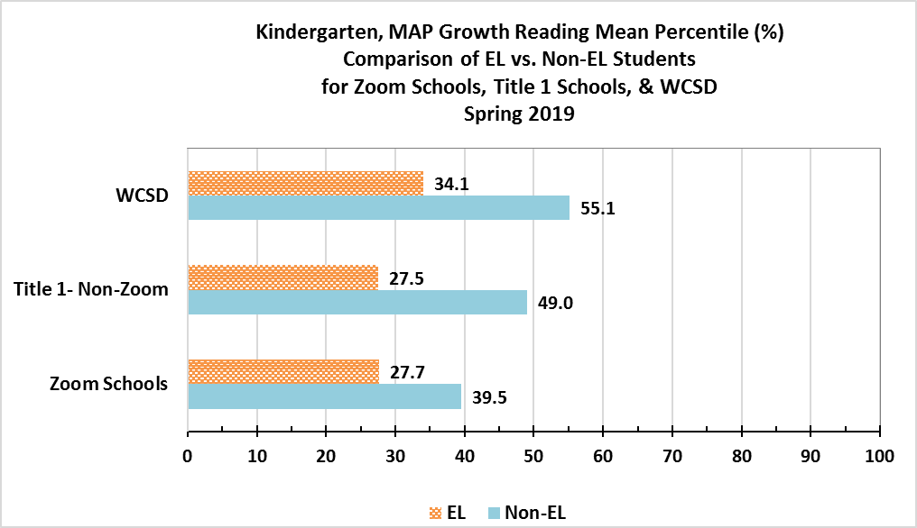

**Figure 2. Comparison of Kindergarten EL students vs. Non-EL students at Zoom Schools,**

**other Title I Non-Zoom schools and WCSD**

Table 4 details results of the Winter 2019 MAP Growth Reading assessment for SY 2019-20. The data were not used to determine student achievement but to provide guidance for support and intervention as necessary. The data present a snapshot in time of how students were performing before the transition to distance learning in the spring.

**Table 4. Percent of Kindergarten Students Meeting >40th Percentile MAP Growth Reading,**

**Winter 2019, SY 2019-20**

| **School Name** | **# Students Testing**  **(N)** | **Kindergarten, Winter 2019**  **% Met >40th Percentile**  **MAP Growth Reading** |
| --- | --- | --- |
| Anderson | 59 | 35.6 |
| Corbett | 45 | 26.6 |
| Duncan | 58 | 25.8 |
| Loder | 71 | 35.2 |
| Mathews | 78 | 32.0 |
| Veterans | 55 | 25.5 |
| Cannan | 73 | 37.0 |
| Sun Valley | 76 | 34.2 |
| K. Smith | 51 | 38.7 |
| Lemelson | 40 | 20.0 |
| Lincoln Park | 57 | 33.4 |
| Allen | 65 | 36.9 |
| Mariposa Charter | Not Available | Not Available |
| Mitchell | 57 | 45.6 |
| Bennett | 74 | 29.8 |
| Greenbrae | 45 | 22.2 |
| Maxwell | 69 | 28.9 |
| Palmer | 87 | 46.0 |
| Risley | 67 | 28.4 |
| Smithridge | 80 | 32.6 |
| **Overall Zoom ES**  **MAP Growth Reading Proficiency** | **1,207** | **32.3%** |

**Grade 1-2 Results:**

In SY 2018-19, the 40th percentile on the MAP Growth Reading assessment was Nevada’s Read by Grade 3 indicator for reading proficiency. Results for Spring 2019 MAP Growth Reading for Grade 1 and Grade 2 are shown in Table 5.

*Grade 1* results show Zoom schools (N=19) that met >40th Percentile Proficiency as follows, (*note—data were not available for Mariposa Charter; totals may not equal 100% due to rounding):*

* 5% (one school) had less than 20% of students that met proficiency.
* 21% (four schools) had 20-29% of students that met proficiency.
* 32% (six schools) had 30-39% of students that met proficiency.
* 26% (five schools) had 40-49% of students that met proficiency.
* 16% (three schools) had 50-59% of students that met proficiency.
* Zoom Schools had an average of 37% of *Grade 1* students that met reading proficiency compared to the overall District at 54%.

Grade 2 results show Zoom schools (N=19) that met the 40th Percentile—Proficiency—as follows, (*note—data were not available for Mariposa Charter; totals may not equal 100% due to rounding):*

* 0% (0 schools) had less than 20% of students that met proficiency.
* 11% (two schools) had 20-29% of students that met proficiency.
* 32% (six schools) had 30-39% of students that met proficiency.
* 47% (nine schools) had 40-49% of students that met proficiency.
* 11% (two schools) had 50-59% of students that met proficiency.
* Zoom Schools had an average of 41% of *Grade 2* students that met proficiency compared to the overall District at 55%.

**Table 5. Percent (%) of Students Meeting >40th Percentile MAP Growth Reading, Spring 2019, Grade 1**

| School Name | Grade 1  Spring 2019  %Met 40th Percentile MAP Growth | Grade 2  Spring 2019  %Met 40th Percentile MAP Growth |
| --- | --- | --- |
| Anderson | 35.1 | 43.7 |
| Corbett | 30.4 | 49.2 |
| Duncan | 20.0 | 21.8 |
| Loder | 17.9 | 22.1 |
| Mathews | 55.8 | 55.7 |
| Veterans | 54.0 | 46.0 |
| Cannan | 32.5 | 33.3 |
| Sun Valley | 38.5 | 40.0 |
| Kate Smith | 23.6 | 43.1 |
| Lemelson | 38.3 | 38.2 |
| Lincoln Park | 40.5 | 40.9 |
| Allen | 46.8 | 39.3 |
| Mariposa Charter | Not Available | Not Available |
| Mitchell | 57.1 | 37.5 |
| Bennett | 25.5 | 38.7 |
| Greenbrae | 41.1 | 41.7 |
| Maxwell | 32.4 | 46.0 |
| Palmer | 44.9 | 54.4 |
| Risley | 27.9 | 37.5 |
| Smithridge | 46.4 | 43.8 |
| Overall Zoom ES: MAP Growth Reading Proficiency | **37.3%** | 40.7% |
| Overall District ES: MAP Growth Reading Proficiency | 54.3% | 55.3% |

Figure 3 provides a comparison of EL students vs. Non-EL students in *Grade 1* at Zoom Schools, other Title I Non-Zoom schools, and WCSD. Results indicate that EL *Grade 1* students are performing slightly less (-1.8%) than other Title I schools and less than (-7.1%) EL *Grade 1* students in the rest of the District.

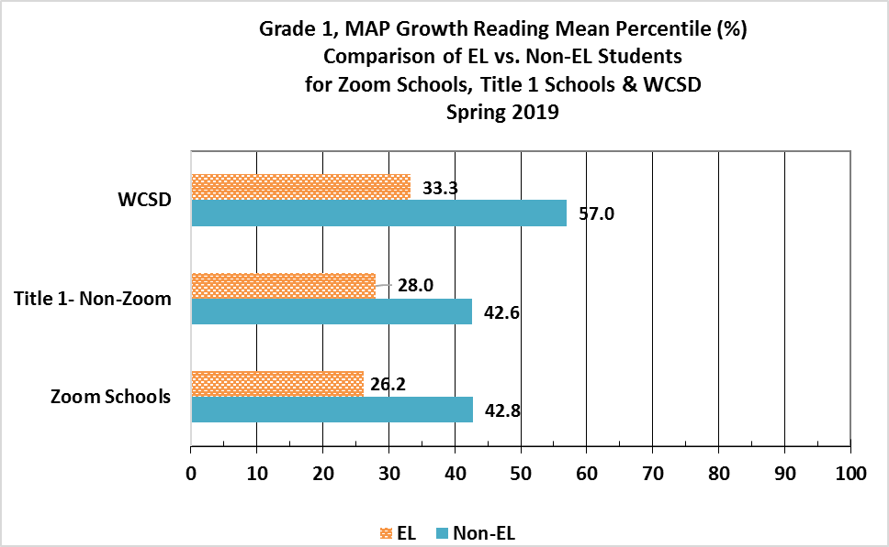

**Figure 3. Comparison of Grade 1 EL students vs. Non-EL students at Zoom Schools,**

**other Title I Non-Zoom schools, & WCSD**

Figure 4 provides a comparison of EL students vs. Non-EL students in *Grade 2* at Zoom Schools, other Title I Non-Zoom schools, and WCSD. Results indicate that EL *Grade 2* students are performing slightly better (+1.3%) than other Title I schools and less than (-5.2%) EL *Grade 2* students in the rest of the District.

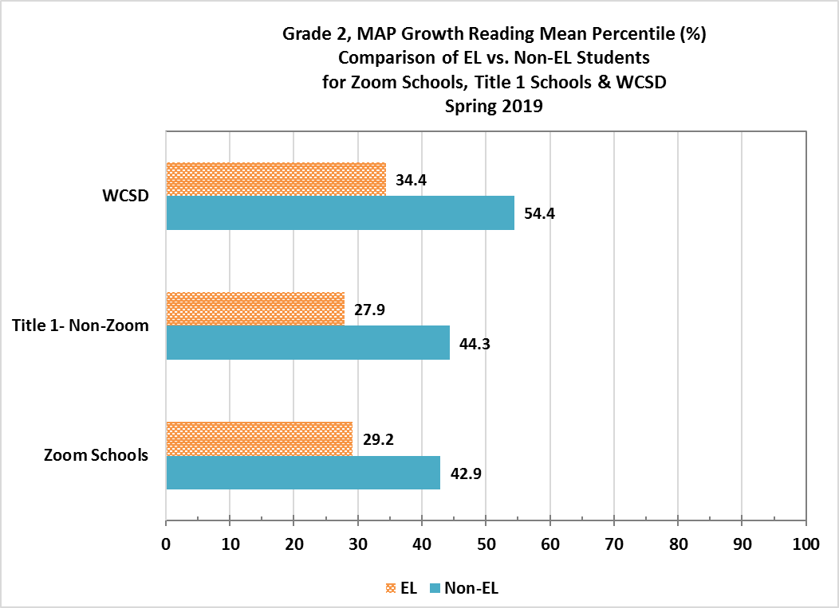

**Figure 4. Comparison of Grade 2 EL students vs. Non-EL students at Zoom Schools,**

**other Title I Non-Zoom schools, & WCSD**

**Smarter Balanced Assessment Consortium (SBAC)-ELA**

SBAC is typically administered at the end of each school year and consists of two parts: a computer adaptive test and a performance task. As Zoom continues to focus on improving students’ English language arts/literacy, the reading proficiency of third graders as measured by SBAC will be a critical external accountability assessment tool used to monitor the overall effectiveness of the Zoom initiative. **NOTE: Due to the transition to distance learning in the spring 2020 caused by the COVID-19 pandemic, SBAC-ELA testing was not administered for SY 2019-20. However, results from previous years are presented in Figure 5 and 6.**

**SBAC-ELA Zoom Elementary Schools Results: Grade 3**

Figure 5 details the percentage of Grade 3 students who met SBAC-ELA AL Level 3 and 4 Proficiency for the SY 2016-17, SY 2017-18, and SY 2018-19. Zoom students showed no change in proficiency—27% for both SY 2017-18 and SY 2018-19, with a slight increase (+3.0%) from SY 2016-17. Overall Zoom students had lower proficiency rates than similar Title I non-Zoom schools who experienced a slight decrease in Grade 3 proficiency from SY 2017-18 to SY 2018-19, 33% to 32%, respectively. WCSD decreased slightly from 45% to 44%, respectively, for SY 2017-18 and SY 2018-19.

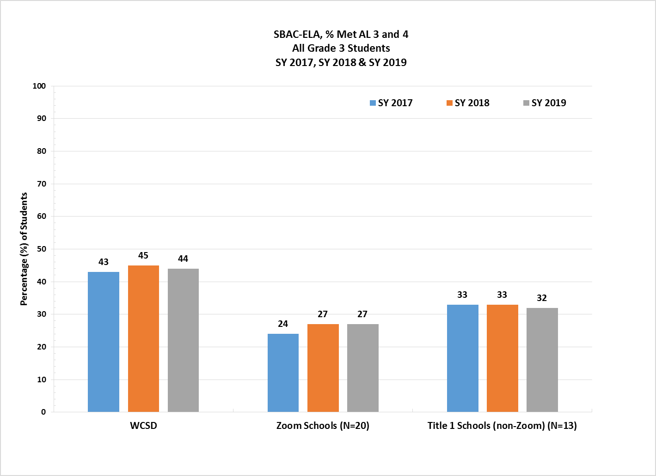

###### Figure 5. WCSD Zoom Elementary Schools, Percent SBAC - ELA - Grade 3 Overall Students

Figure 6 details the percentage of Grade 3 EL students who met SBAC-ELA AL Level 3 and 4 Proficiency for SY 2016-17, SY 2017-18, and SY 2018-19. EL students at Zoom schools showed a decrease in 3rd-grade ELA proficiency, from 17% to 14%, from SY 2017-18 and SY 2018-19. They had lower proficiency rates than other Title I non-Zoom schools that experienced an increase in proficiency from 19% to 21% during, from SY 2017-18 to SY 2018-19. Grade 3 EL students in WCSD showed no change in proficiency between SY 2017-18 and SY 2018-19, staying at 18%.

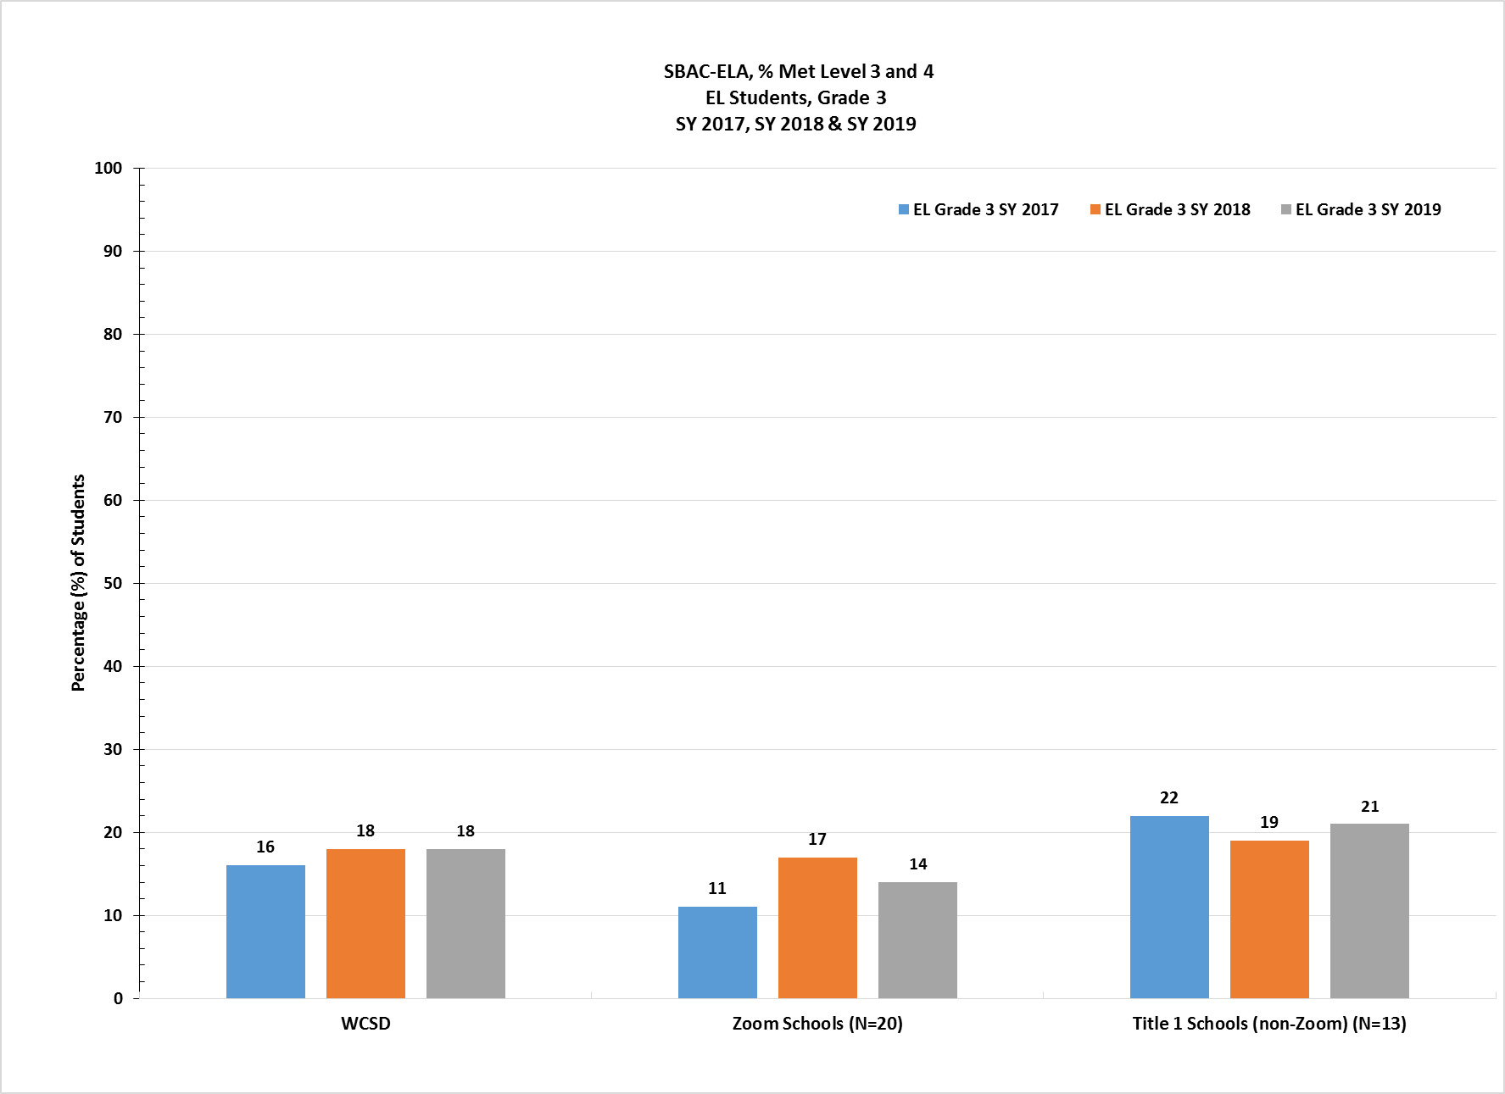

###### Figure 6. WCSD Zoom Elementary Schools, Percent SBAC–ELA Grade 3 EL Students

# ACCESS Exit Rates for English Learners (EL)—Zoom Elementary Schools

The ACCESS (Assessing Comprehension and Communication in English State-to-State for English Learners) is an annual summative assessment of the developing social and academic English language proficiency for EL students in kindergarten through 12th grade.

As shown in Figure 7, results indicate WCSD Zoom schools showed a slight increase of 0.8% in the total number of students exited between SY 2018-19 and SY 2019-20, from 11.8% to 12.5%. Zoom school students also exited at a slightly higher rate than similar Title I non-Zoom schools in SY 2019-20 - 12.5% versus 11.0% in SY 2018-19.

The overall exit rates for WCSD elementary schools show an increase between SY 2018-19 and SY 2019-20, from 10.8% to 13.0%, and an increase of 0.5% compared to Zoom schools. WCSD is also 2.0% higher than similar Title I non-Zoom schools, 13.0% vs. 11.0%, respectively.

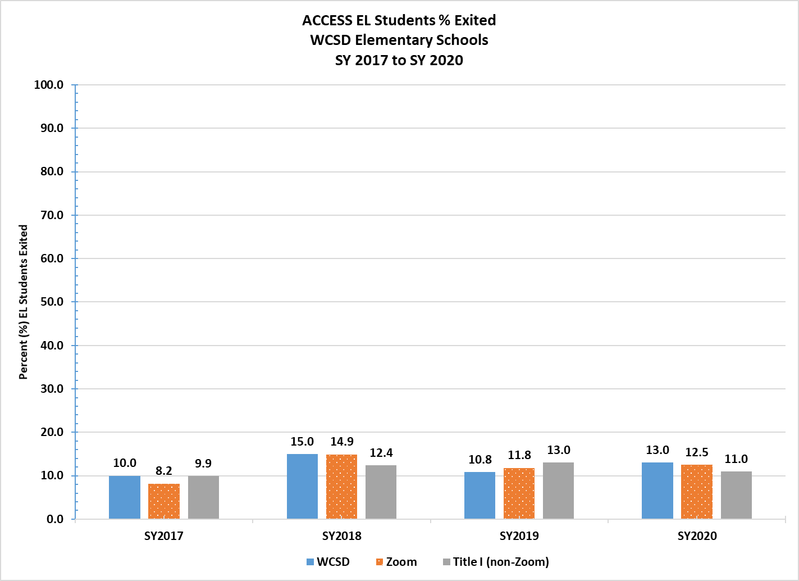

**Figure 7. Comparison of WCSD Elementary Schools, EL Students Percent Exit Rates,**

**SY 2016-17 to SY 2019-20**

**Nevada Growth Model (NGM) – English Learners’ AGP Performance**

# Elementary School Results

The NGM measures student growth on state assessments compared to other students in the state with a similar score history. The AGP on the ACCESS test is the Student Growth Percentile (SGP) an EL student needs to stay on track to reach a proficient level within five years or by grade 10.

**NOTE:** In accordance with the U.S. Department of Education ESEA waiver to suspend accountability requirements in response to the COVID-19 pandemic, the following directions from the Nevada Department of Education were implemented (Retrieved on December 7, 2020 from [Nevada Report Card PPT](http://nevadareportcard.nv.gov/DI/MoreDownload?filename=Nevada%20Report%20Card%202019-2020.pdf); and [Nevada Report Card](http://nevadareportcard.nv.gov/di/)):

* **NSPF Star Ratings**  
  NSPF school ratings and accountability indicators have been carried over from the 2018-19 reporting year.  State and District information that can be reported for the current reporting year such as student enrollment, graduation rates, etc. will be reported. The most recent NSPF school rating report should be presented for SY 2018-19.
* **Assessment Results**  
  All state assessments and reporting of assessments are waived for SY 2019-20. The most recent academic achievement results should be presented for the SY 2018-19 reporting year.

Additionally, NDE has established recommended performance levels and outcome indicators for Zoom funded schools. It is important to note that the AGP is only one of several measures used to evaluate progress of EL students in the state. NDE recommended the AGP performance target for Zoom schools be set at the 50th percentile, as shown in Table 6, for all elementary schools with sufficient N-count of EL students (adopted by SBE in June 2016).

Table 7 shows the percentage of students at each WCSD Zoom elementary school that met AGP on the SY 2019-20 ACCESS exam, with seven (35%) schools demonstrating slight positive growth, and 13 (65%) schools showing a decrease in AGP.

*[Star Ratings are shown for SY 2018-19 as directed by NDE. A comparison of star ratings between SY 2017-18 and SY 2018-19 show that seven (35%) schools increased their rating, 11 (55%) maintained the same rating, and only two (10%) schools decreased by one star for SY 2018-19.]*

**Table 6. Quartile Ranking, WCSD Zoom Elementary Schools, SY 2018-19**

| ELEM Schools: 343 | Half Midpoint 171.5 | Median 85.75 |  |
| --- | --- | --- | --- |
| *At or Below the*  *25th Percentile* | ***Below the***  ***50th Percentile*** | ***Above the***  ***50th Percentile*** | ***At or Above the***  ***75th Percentile*** |
| 0.00%≤ 39.99% | 40.00% ≥47.90% | **47.91%** ≥ 56.91% | 56.92.%≤ |

**Table 7. WCSD Zoom Elementary Schools, SY 2019-20**

**Percent EL Students Who Met WIDA Adequate Growth Percentile (AGP)**

| Original Funding Year | School Name  *(*Denotes*  *Corrective Action School)* | 2018 Star Rating | Trend | 2019 Star Rating | 2019 NSPF Total Index Score | 2018  % EL Met AGP | 2019  % EL Met AGP | 2020  % EL Met AGP | AGP Diff. from 2019 to 2020 |
| --- | --- | --- | --- | --- | --- | --- | --- | --- | --- |
| 2016 | Smithridge ES | 2 |  | 2 | 48.5 | 62.10 | 53.8 | 44.0 | -9.8 |
| 2015 | Lincoln Park ES | 2 |  | 2 | 27.0 | 60.44 | 44.4 | 48.0 | 3.6 |
| 2016 | Palmer ES | 2 |  | 3 | 52.5 | 56.0 | 55.4 | 60.0 | 4.6 |
| 2015 | Mitchell ES | 2 |  | 2 | 29.0 | 57.0 | 37.0 | 41.0 | 4.0 |
| 2016 | Greenbrae ES | 2 |  | 2 | 47.5 | 56.52 | 57.0 | 50.0 | -7.0 |
| 2016 | ***\**** Maxwell ES | 3 |  | 4 | 79.5 | 54.0 | 48.6 | 47.0 | -1.6 |
| 2013 | ***\**** Lemelson ES | 3 |  | 3 | 56.0 | 57.0 | 34.2 | 48.0 | 13.8 |
| 2016 | ***\**** Risley ES | 3 |  | 2 | 37.0 | 55.26 | 38.0 | 33.0 | -5.0 |
| 2016 | Bennett ES | 2 |  | 2 | 47.0 | 52.50 | 53.0 | 34.0 | -19.0 |
| 2013 | ***\**** Corbett ES | 2 |  | 4 | 69.5 | 51.61 | 56.2 | 51.0 | -5.2 |
| 2015 | Allen ES | 2 |  | 2 | 36.0 | 51.85 | 42.9 | 47.0 | 4.1 |
| 2013 | ***\**** Loder ES | 1 |  | 2 | 32.5 | 47.66 | 44.4 | 43.0 | -1.4 |
| 2015 | ***\**** Smith Kate ES | 2 |  | 2 | 47.5 | 46.67 | 58.8 | 45.0 | -13.8 |
| 2014 | ***\**** Sun Valley ES | 2 |  | 2 | 47.5 | 46.92 | 51.0 | 47.0 | -4.0 |
| 2013 | Anderson ES | 1 |  | 1 | 18.5 | 46.70 | 38.0 | 34.0 | -4.0 |
| 2014 | ***\**** Cannan ES | 1 |  | 2 | 28.5 | 45.39 | 45.7 | 39.0 | -6.7 |
| 2013 | Duncan ES | 1 |  | 2 | 32.0 | 42.95 | 42.0 | 44.0 | 2.0 |
| 2013 | Mathews ES | 1 |  | 2 | 29.0 | 40.69 | 52.0 | 30.0 | -22.0 |
| 2013 | ***\**** Veterans ES | 2 |  | 1 | 23.0 | 39.69 | 32.0 | 41.0 | 9.0 |
| 2015 | ***\**** Mariposa ES | 2 |  | 2 | 34.5 | 38.0 | 59.2 | 48.0 | -11.2 |

# Zoom Elementary School Extended Day

During SY 2019-20, WCSD Zoom elementary schools continued to offer extended learning day to students beyond the normal school day. All of the Zoom schools who also had 21st Century Community Learning Center (21st CCLC) / TEAM UP chose to use the Academic Hour of 21st CCLC/TEAM UP as their extended learning day. In the past, these schools had chosen to run both 21st CCLC/TEAM UP and Zoom extended day. That model resulted in competing initiatives, with neither one being able to attract enough teachers and/or students. By focusing only on the 21st CCLC/TEAM UP in SY 2019-20, schools were able to have more consistent staffing, student enrollment, and instruction. Elementary schools that did not have the 21st CCLC/TEAM UP program continued to run their own extended day program.

***Extended Learning Day – 21st CCLC/TEAM UP Program***

The extended day program used the 21st CCLC/TEAM UP model, where students were targeted for the 21st CCLC/TEAM UP using each school’s MTSS process. The 21st CCLC/TEAM UP academic hour is considered a Tier 2 intervention for ELA and/or Math. The program is administered in three separate sessions and adjusted based on the needs of the students and includes extra opportunities for students to read and apply math concepts that support future learning and academic growth/ achievement. The enrichment hour also provides additional support in STEM education, Civics education, Anti-bullying, Social Emotional Learning, Nutrition/Physical Fitness, Drug/Alcohol Prevention, Character Education, and Arts education. Students attend 21st CCLC/TEAM UP five days-per-week at the elementary level. Student enrollment totals in the 21st CCLC/TEAM UP at Zoom elementary schools are shown in Table 8.

**Table 8. Extended Day: Team Up Enrollment by Zoom Elementary School,**

**SY 2019-20**

| **School Name** | **# of Students Enrolled in 21st CCLC/ TEAM UP** | **# of EL Students Enrolled in 21st CCLC/TEAM UP** |
| --- | --- | --- |
| Allen | 116 | 4 |
| Anderson | 95 | 0 |
| Cannan | 93 | 27 |
| Corbett | 100 | 18 |
| Duncan | 100 | 38 |
| Greenbrae | 111 | 52 |
| K. Smith | 91 | 49 |
| Lemelson | 126 | 13 |
| Loder | 78 | 26 |
| Mathews | 91 | 3 |
| Maxwell | 72 | 10 |
| Mitchell | 93 | 16 |
| Smithridge | 108 | 50 |
| Sun Valley | 82 | 24 |
| Veterans | 62 | 8 |
| **Total Student Enrollment:** | **1,418** | **338** |

**General Overview of TEAM UP Elementary Academic Hour**

The 21st CCLC/TEAM UP staff supports and monitors the reading activities implemented by teachers at the various 21st CCLC/TEAM UP sites. The academic hour of the 21st CCLC/TEAM UP aligns with the NVACS “all students are college and career ready in literacy no later than the end of high school.” ELA standards embedded into the curriculum include:

* Reading and comprehending a variety of complex texts;
* Writing and responding to text and research;
* Communicating and collaborating with peers; and
* Utilizing language and vocabulary appropriately.

**The Fountas & Pinnell Classroom™ Guided Reading Collection:** Is *used during the academic hour of the program in a small-group instructional context. The curriculum supports each reader’s ability to read new and* challenging texts. Curriculum is systematically constructed to develop students’ reading ability by guiding them to process text that is ability leveled.

**Benchmark Advance**: This is part of WCSD’s NDE-approved adopted ELA curriculum and is designed for students to master rigorous learning goals with the support of strong differentiated instruction and responsive teaching based on ongoing assessment. In *Benchmark* *Advance*, there are the four key foundational areas—print concepts, phonological awareness, phonics and word recognition, and fluency—are integrated into the meaningful context of each unit.

**Phonics First®:** Thiscurriculum is used during the academic hour and adheres to new Common Core State Standards and meets Learning Forward’s standards for professional development. *Phonics First®* programs are accredited through both the IDA (International Dyslexia Association) under their Knowledge and Practice Standards for Teachers of Reading and through IMSLEC (International Multisensory Structured Language Education Council) at the Teaching Level and Instructor of Teaching Levels.

*Please note:* Both Fountas & Pinnell and Phonics First are in place via Read by Grade Three, Zoom, and Victory programming. Other ELA interventions are iReady Diagnostic/Intervention, RAZ Kids, A-Z Reading Books (all ESSA Evidence 1-3).

**MATH ACTIVITIES:** Teachers submit the program’s weekly lesson plans to the site leader and site administrator. Teachers post learning objectives and promote “I can” statements to assist in skill and knowledge acquisition, which are essential to student learning.

The academic hour of the 21st CCLC/TEAM UP Program aligns with the NVACS and focus on “processes and proficiencies” of mathematical practices. The National Council of Teachers of Mathematics (NCTM) emphasizes student problem solving, reasoning and proof, communication, representation, and connections. Teachers also use a variety of research based instructional strategies to assist students in the learning process. Students have opportunities to practice their skills both formally and informally. Students will learn to:

* Access a variety of math concepts, mnemonics, and procedures;
* Calculate with accuracy and fluency of math facts; and
* Apply mathematical knowledge correctly.

**Bridges in Mathematics:** This program, in the Math Learning Center, was used for kindergarten and 1st grades. This comprehensive curriculum aligns with NVACS and focuses on mathematical concepts, proficiency with key skills, and the ability to solve complex problems.

**enVision Mathematics 2.0:** This program,from Pearson Publishing, was used for grades 2-5. This mathematical curriculum aligns with NVACS and provides resources to assist all levels of learners. The curriculum teaches problem-based learning embedding student conversations. Lessons reinforce math practices, performance tasks, and higher order thinking (Depth of Knowledge). Additional ESSA evidence-based math activities and programs (Levels 1-3) include PLATO, Study Island, and DreamBox.

**College and Career Readiness:** Career and Technical Education (CTE) is a key objective in the District’s strategic plan, *Envision 2020*, Goal 1: Ensure annual student academic growth through a vertically aligned system of curriculum and instruction founded on rigorous and relevant instruction designed to meet the needs of every child in our student population. All District school’s SPP must have goals and objectives that are preparing students along The Pathway to graduate career and college ready.

**Impact of COVID-19 on TEAM UP Extended Learning Day Model:** The impact of COVID-19 was significant for SY 2019-20. WCSD chose not to provide any virtual after school programming from Spring Break to the end of the year. The focus for program staff was professional development and supporting the regular day with parent/student communication. This was an option provided to WCSD by NDE. Due to COVID-19, MAP data was not collected for spring 2020.

**Extended Learning Day – School Based Model:** Four of the Zoom elementary schools did not have the 21st CCLC / TEAM UP last year and ran their own extended day programs as outlined below:

* **Agnes Risley’s** ELD program in SY 2019-20 focused on reading with a specific emphasis on foundational skills. The Avenues curriculum was used to support instruction. Twenty EL students were selected to participate based on their Access Data and reading level. This program was staffed by six teachers who each worked with either individual or small groups of students four days a week for one hour. Teachers used running records to monitor student progress. Throughout the length of the program, student attendance was an ongoing issue. Students were not consistently attending, which impacted student progress. Due to COVID-19 and the shift to distance learning, Risley’s ELD programming ended early.
* **Esther Bennett’s** SY 2019-20 extended learning day program focused on reading, writing, phonics and word study through the use of Reading A-Z and Fountas and Pinnell. School staff selected 30 students to participate in this program based on the criteria that they were flagged as a student who would receive T2 services based on their Benchmark assessment by Fountas and Pinnell. Eighteen of the students who were selected were English Learners. Seven teachers worked with small groups of students three days a week for 45 minutes before school and used a combination of benchmark assessments, running records, and observation notes to monitor student progress. Although the program ended early due to COVID-19 and the transition to distance learning, many students increased one or two levels on their Benchmark assessments.
* **Lincoln Park’s** extended learning day program for SY 2019-20 focused on reading comprehension, vocabulary, and fluency through the use of the District’s adopted ELA curriculum and chapter books for the other students. Teachers worked with students to reteach things that were being taught in the classroom and focus on basic reading skills. Two teachers worked with a total of about 10 students in small groups four days per week for 30 minutes each day. Student attendance and family commitment to the program was an on-going challenge and resulted in a revolving door of students. Initially, students who were identified to receive Tier 2 and Tier 3 intervention were also EL.
* **Virginia Palmer’s** extended learning day program focused on reading skills through the use of Leveled Literacy Intervention (LLI) for 1st-5th grades and Phonics First for kindergarten students. Teachers selected students to participate in the program based on EL status if they were falling below grade level in reading and family commitment to the program. Ten teachers worked with small groups of students four days a week for one hour. A total of 60 students participated, and 40 of those students were EL. Throughout the three months of ELD, students were monitored using running records and Aimsweb data. Due to COVID-19, the program had to end early. Based on MTSS data, those students who participated in the program made average growth.

Table 9 outlines the amount of Zoom funds spent on the school-based models only. No Zoom funding was needed to support the 21st CCLC/TEAM UP TEAM UP Academic Hour model.

**Table 9. WCSD Zoom Elementary Schools Extended Day Cost-Per-Student, SY 2019-20**

| School Year | $ Total Cost of Extended Day | Number of Students Served | $ Cost-Per-Student |
| --- | --- | --- | --- |
| 2019—2020 | $38,022 | 120 | $317 |

**Zoom Middle Schools - Program Assessment Results**

Zoom middle schools—Dilworth, Sparks, Traner, and Vaughn—created and fostered a literacy environment to improve the culture with a focus on language and literacy development for all students. Specific Zoom goals at the middle school level included the following key components:

1. Reduce class sizes for EL students and provide English language literacy-based classes;
2. Direct instructional intervention to each EL student using data from assessments;
3. Intersession and/or Extended Day intervention activities; and
4. Other evidence-based programs and services approved by NDE.

**Zoom Reduced Class Size and Direct Instructional Intervention**

Through responsible scheduling, middle schools continued to identify and target students based on ACCESS/WIDA/ELPA assessment results, current coding as EL students, and other assessment data to drive responsible scheduling into classes taught by certified teachers with a TESL endorsement.

Each middle school used Zoom funds to hire additional highly-qualified staff ranging from EL teacher assistants to highly qualified EL teachers as a strategy to reduce class sizes to be more responsive to EL students’ needs. For example, Dilworth Middle School hired an interventionist that was able to push into EL and ELA classes that had a high number of EL students. This individual provided targeted language and content support to students on a daily basis. Table 10 presents the total cost, number of students served, and cost per student for reduced class size and direct instructional intervention funding.

**Table 10. WCSD Zoom Schools, Reduced Class Size and Direct Instructional Intervention:**

**Cost-Per-Student, SY 2019-20**

| School Year | Total Cost of Reduced Class Size/Intervention | Number of  Students Served | Cost-Per-Student |
| --- | --- | --- | --- |
| 2019—2020 | $821,080 | 2,861 | $287 |

**Other Evidence-based Programs and Services Approved by NDE:**

Zoom middle schools also provided additional classes and programs to advance language and academic achievement. For example:

* At Dilworth Middle School, Zoom funds were used to hire a full time AVID teacher. This teacher was able to offer an AVID elective to students that focused on WICOR: writing, inquiry, collaboration, organization and reading. This class not only helped students advance their reading and writing skills, but it helped to teach them important academic practices that they could apply across content.
* Traner Middle School and Dilworth Middle School purchased Achieve 3000. Achieve 3000 aims to differentiate and accelerate individual student achievement through high quality instruction and materials. These materials and instructional practices were used to supplement core instruction, intervention, and Special Education.

* All four middle schools purchased ELLevation. As described in the elementary reading skills center portion of this report, ELLevation was used at the middle school level to support teachers planning and implementation of intentional language instruction and support into content area lessons.

Table 11 presents the total cost of other evidence-based programs and services, and cost per student.

**Table 11. WCSD Zoom Schools, Other Evidence-Based Programs and Services:**

**Cost-Per-Student, SY 2019-20**

| School Year | Total Cost of Other Programs | Number of  Students Served | Cost-Per-Student |
| --- | --- | --- | --- |
| 2019—2020 | $295,780 | 2,861 | $103 |

**Zoom Middle School Extended Learning Day:**

Each middle school provided an Extended Learning Day time as an intervention to support the language and literacy development for EL students. Schools did not choose to run intersession programs in SY 2019-20 as student attendance and teacher recruitment proved to pose challenges in years past. Vaughn and Sparks middle schools already had a 21st CCLC/TEAM UP and chose to use the academic hour for their extended learning day. The other two schools designed and implemented their own school-based extended learning day program.

**Extended Learning Day–TEAM UP Model**

Students are targeted for the 21st CCLC/TEM UP using the school site’s MTSS process. The program’s academic hour is considered a Tier 2 intervention for ELA and/or math. The program runs in three separate sessions and adjusted based on the needs of the students and includes extra opportunities for students to read and apply math concepts that support future learning and academic growth/ achievement. The enrichment hour also provides additional support in STEM education, Civics education, Anti-bullying, Social Emotional Learning, Nutrition/Physical Fitness, Drug/Alcohol Prevention, Character Education, and Arts education. Middle school students generally attend TEAM UP Academic Hour, but an additional day is sometimes added for additional support or for special events. Student enrollment is shown in Table 12.

**Table 12. Extended Day: 21st CCLC/TEAM UP Program Enrollment by Zoom Middle School,**

**SY 2019-20**

| **School Name** | **Total # of Students** | **# of EL Students** |
| --- | --- | --- |
| Sparks MS | 120 | 39 |
| Vaughn MS | 68 | 9 |

**General overview of middle school academic hour:**

The middle school model is similar to the elementary school model outlined in the elementary section of this report since these sites also service 6th grade. Middle school students receive intervention in ELA and Mathematics. Most of their support is targeted towards mini-instructional lessons coupled with homework assistance. The middle schools also focus on the AVID curriculum which includes reinforcing academic behaviors and higher-level thinking. Students learn about organization, study skills, communication, and self-advocacy.

**Impact of COVID-19 on TEAM UP Extended Learning Day Model:**

The impact of COVID-19 was significant for SY 2019-20. WCSD chose not to provide any virtual after-school programming from Spring Break to the end of the year. The focus for program staff was professional development and supporting the regular day with parent/student communication. This was an option provided to WCSD by NDE. Due to COVID-19, MAPS data was not collected for the end of year.

**Extended Learning Day – School-Based Model**

Two of the Zoom middle schools, Traner and Dilworth, did not have 21st CCLC/TEAM UP and ran school-based extended learning day models as outlined below:

* **Traner Middle School’s** extended learning day focused around supporting reading, speaking, and listening skills. Lexia, Read 180, and student’s classwork were used to support instruction. Students were selected on a voluntary basis and through EL teacher recommendations. A total of eight teachers supported 83 students, 51 being EL. The program ran three days per week for one hour and also occurred on four Saturdays for three hours each. The intent was to look at MAP/SBAC data to determine student growth; however, due to COVID-19, that data was not collected. Eighty-five percent of the students who participated had a higher grade in ELA and Math in 3rd quarter than in 1st quarter.
* **Dilworth Middle School** ran an after-school extended studies program that provided additional instructional support and intervention to students identified through a combination of data review, teacher recommendation and parent recommendation. Students were placed in the program for at least a unit of instruction (three to four weeks) and often longer based on need. The program was fluid and served approximately 35 students each month. Due to COVID-19, this program ended abruptly at spring break and did not continue during the distance learning portion of the 4th quarter.

Table 13 outlines the expenses for the school-based extended day models only. Zoom money was not spent on the 21st CCLC/TEAM UP Model because it has its own funding source.

**Table 13. WCSD Zoom Schools, Extended Learning Day: Cost-Per-Student,**

**SY 2019-20**

| School Year | Total Cost of Extended Learning Day | Number of  Students Served | Cost-Per-Student |
| --- | --- | --- | --- |
| 2019—2020 | $31,606 | 118 | $268 |

**SBAC–ELA Zoom Middle Schools**

**NOTE: Due to the school closures in the spring 2020 caused by the COVID-19 pandemic, SBAC-ELA testing was not administered for SY 2019-20. However, results from previous years are presented in Figures 14 and 15.** Figure 14 details the percentage of Grade 8 students overall who met SBAC-ELA AL Level 3 and 4 Proficiency for *SY 2016-17, SY 2017-18, and SY 2018-19*. Students at Zoom schools showed an increase from 32% to 35%, between SY 2017-18 and SY 2018-19, respectively. Zoom school proficiency rates were higher at 35% in SY 2018-19 than similar Title I non-Zoom schools who showed a decrease of 44% to 31% between SY 2017-18 and SY 2018-19. Additionally, WCSD 8th grade students performed higher with 50% proficiency vs. Zoom Schools at 35%, and Title I schools at 31% in SY 2018-19.

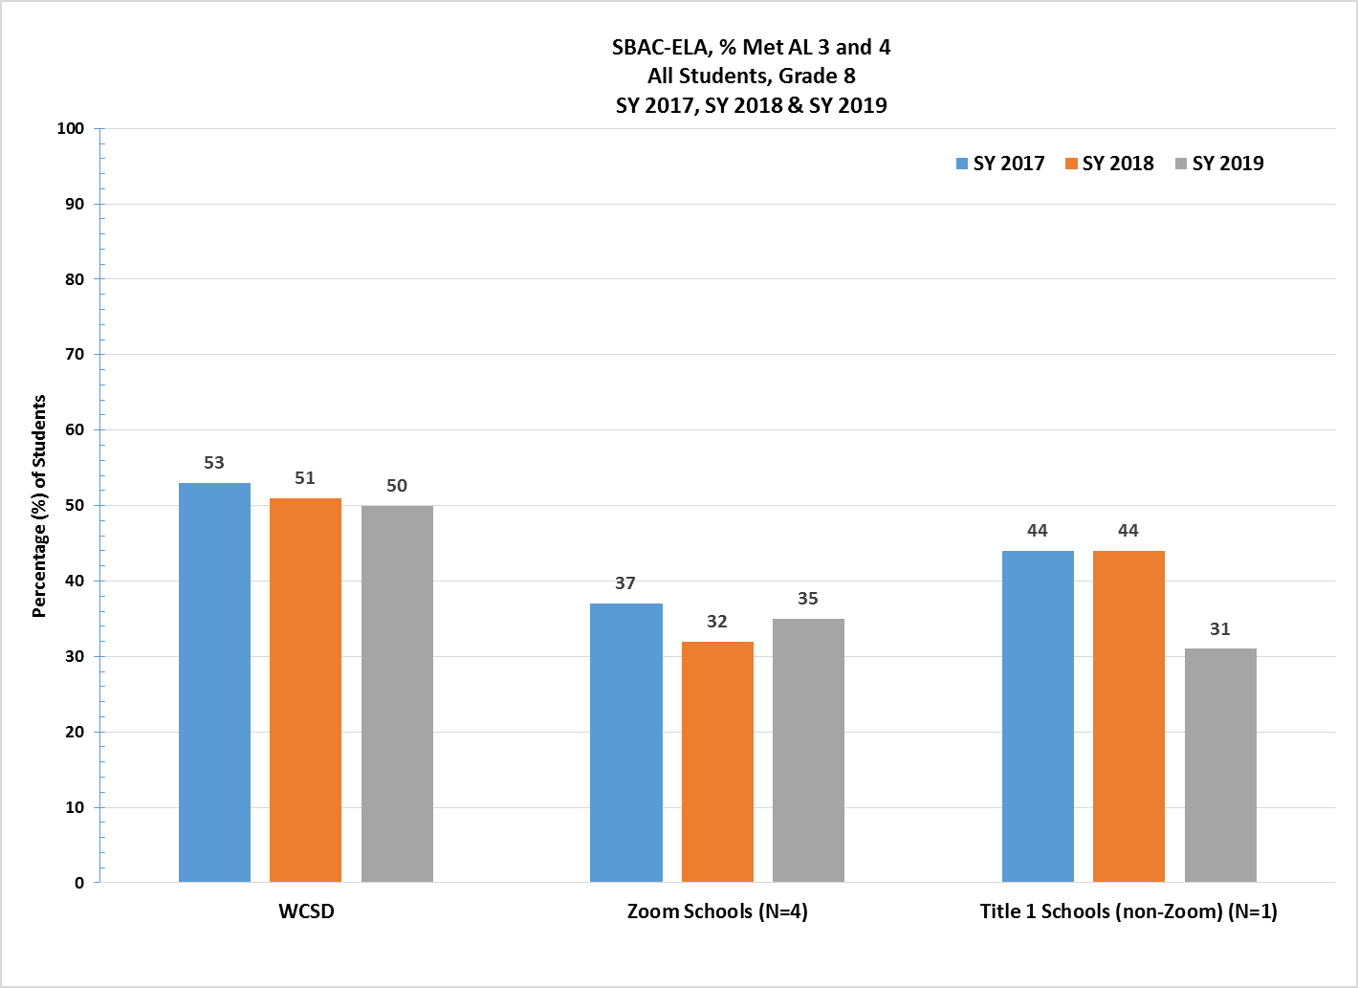

**Figure 14. WCSD Zoom Middle Schools, Percent SBAC — ELA Grade 8 Overall Students,**

**SY 2016-17, SY 2017-18, & SY 2018-19**

Figure 15 details the percentage of Grade 8 EL students who met SBAC-ELA AL Level 3 and 4 Proficiency for the SY 2016-17, SY 2017-18, and SY 2018-19. EL students at Zoom schools showed no change at 5%, between SY 2017-18 and SY 2018-19; and was the same as similar Title I non-Zoom schools who experienced a decrease from 8% to 5%, between SY 2017-18 and SY 2018-19, respectively. WCSD 8th grade EL students showed an increase from 5% to 7% between SY 2017-18 and SY 2018-19 and was higher than Zoom and similar Title I schools for SY 2018-19.

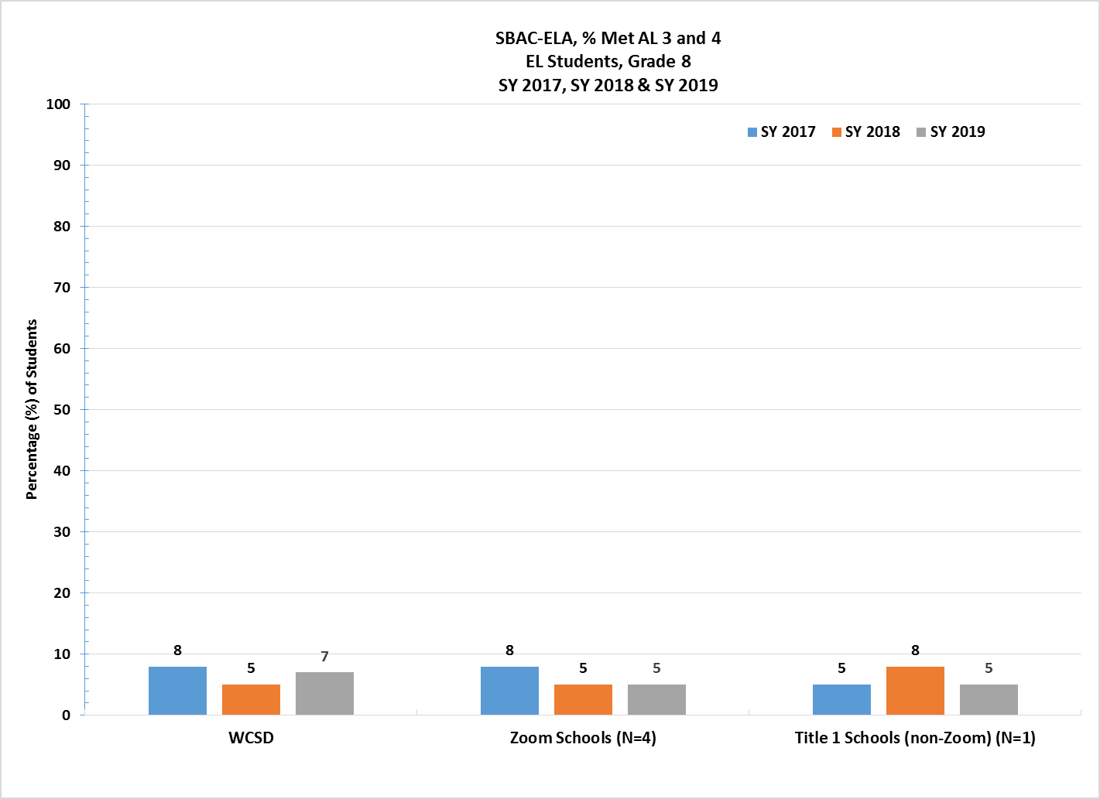

**Figure 15. WCSD Zoom Middle Schools, Percent SBAC – ELA Grade 8 EL Students,**

**SY 2016-17, SY 2017-18 & SY 2018-19**

# ACCESS Exit Rates for English Learners (EL)—Zoom Middle Schools

The ACCESS (Assessing Comprehension and Communication in English State-to-State for English Learners) is an annual summative assessment of the developing social and academic English language proficiency for EL students in kindergarten through 12th grade.

In Figure 16, results for SY 2019-20 indicate that WCSD Zoom middle schools showed a decrease of 2.1% in the total number of students exited between SY 2018-19 and SY 2019-20, from 6.7% to 4.6%. Additionally, Zoom middle schools exited at a higher rate than similar Title I non-Zoom schools did in SY 2019-20, 4.6% versus 3.0%. The results for WCSD middle schools overall show a decrease of 2.2% between SY 2018-19 and SY 2019-20.

###### This graph shows a comparison of WCSD middle schools, exit rates for EL students between School year 2017 to school year 2020.

**Figure 16. Comparison of WCSD Middle Schools, EL Students ACCESS Percent Exit Rates**

**SY 2016-17 to SY 2019-20**

###### Nevada Growth Model (NGM)—English Learners’ AGP Performance:

###### Middle School Results

The NGM measures student growth on state assessments compared to other students in the state with a similar score history. The AGP on the ACCESS test is the SGP an EL student needs to stay on track to reach a proficient level within five years or by grade 10.

**NOTE:** In accordance with the U.S. Department of Education ESEA waiver to suspend accountability requirements in response to the COVID 19 pandemic, please review the following direction from the Nevada Department of Education (Retrieved on December 7, 2020 from [Nevada Report Card PPT](http://nevadareportcard.nv.gov/DI/MoreDownload?filename=Nevada%20Report%20Card%202019-2020.pdf); and [Nevada Report Card](http://nevadareportcard.nv.gov/di/)):

* **NSPF Star Ratings**  
  NSPF school ratings and accountability indicators have been carried over from the 2018-2019 reporting year. State and District information that can be reported for the current reporting year such as student enrollment, graduation rates, etc. will be reported. The most recent NSPF school rating report is presented for SY 2018-19.
* **Assessment Results**  
  All state assessments and reporting of assessments are waived for SY 2019-20. The most recent academic achievement results are presented for SY 2018-19.

NDE recommended the AGP performance target for Zoom schools be set at the 50th percentile, as shown in Table 14, for all middle schools in the State with sufficient N-count of EL students (adopted by State Board of Education, June 2016). Table 14 shows the percentage of students at each WCSD Zoom middle school who met AGP on the SY 2019-20 ACCESS assessment.

Results in Table 15 show that three Zoom middle schools showed a slight decline in AGP between SY 2018-19 and SY 2019-20. *[Star Ratings are shown for SY 2018-19 as directed by NDE. Between SY 2017-18 and SY 2018-19, two schools maintained their rating, and two schools increased their Star Rating by one star.]*

###### Table 14. Quartile Ranking, WCSD Zoom Middle Schools

###### SY 2019-20

| Middle Schools: 96 |  | Median 48.00 |  |
| --- | --- | --- | --- |
| *At or Below the*  *25th Percentile* | ***Below the***  ***50th Percentile*** | ***Above the***  ***50th Percentile*** | ***At or Above the***  ***75th Percentile*** |
| 0.00%≤23.99% | 24.00% ≥35.33% | 35.34% ≥ 48.10% | 48.11%≤ |

**Table 15. WCSD Zoom Middle Schools, SY 2019-20**

**Percent EL Students Who Met WIDA Adequate Growth Percentile (AGP)**

| Original Funding Year | School Name | 2018 Star Rating | Trend | 2019 Star Rating | 2019 NSPF Total Index Score | 2018  % EL Met AGP | 2019  % EL Met AGP | 2020  % EL Met AGP | AGP Diff. from 2019 to 2020 |
| --- | --- | --- | --- | --- | --- | --- | --- | --- | --- |
| 2016 | Sparks MS | 2 |  | 2 | 46.0 | 54.0 | 37.20 | 38.0 | 0.8 |
| 2016 | Dilworth MS | 2 |  | 2 | 41.0 | 48.84 | 26.80 | 22.0 | -4.8 |
| 2015 | Traner MS | 1 |  | 2 | 34.5 | 34.87 | 9.90 | 9.0 | -0.9 |
| 2016 | Vaughn MS | 1 |  | 2 | 32.0 | 22.0 | 14.0 | 13.0 | -1.0 |

**Corrective Action Schools**

The Nevada State Board of Education (SBE) has determined that the primary indicator for determining Zoom schools identified as “in need of improvement” is the percentage of English Learners achieving AGP. NDE annually prepares a quartile ranking of all schools in Nevada with sufficient “n” based on WIDA language proficiency growth scores. **Zoom schools below the 25th percentile of Nevada schools for the ACCESS AGP are identified for improvement.** The Nevada SBE established statewide performance levels and outcome indicators for Zoom schools adopting ESSA Long-Term Goals and Measures for Interim Progress.

The Corrective Action Plan (CAP) outlines how each school will address the needs of EL students and improve the percentage of students achieving adequate growth toward English language acquisition. Each CAP plan includes the following priority-focused action statements, emphasizing evidence-based priorities with the greatest potential to address root causes:

* **Priority 1:** Teachers lacked an understanding of the stages of development for language for a second language learner. As a result, teachers struggled to extend students’ language progress through the process of lesson plans that create the contexts for meaningful language use within the settings that integrate content and academic language learning. Building teacher-capacity continued to be critical in the implementation of language rich strategies and activities that provided opportunities for EL students to make progress in the four domains of language.
* **Priority 2:** Teachers lacked an understanding of formative and summative language assessment practices that were designed to advance the academic achievement and academic language development for culturally and linguistically diverse students. Building teacher-capacity to use language data to backward plan for student language proficiency outcomes continued to play a critical role to gain understanding of language development practices that are crucial for second language learners to become proficient in English.
* **Priority 3:** Teachers lacked an understanding of how to utilize the Interim Assessment Block (IAB) portion of the SBAC Interim package (or may choose to use School City interim assessment tools) as classroom instructional activities. Teachers used the IABs throughout the school year to focus on a set of ELA and Mathematics concepts as an instructional tool during the appropriate unit of study. Teachers were able to provide a practice opportunity for students as they monitored and facilitated classroom discussions of items that align to the Smarter Summative Assessment Blueprint. This continues to be critical in aligning the language development to practice opportunities that prepares students for the types of items found on SBAC, so that ELs increase achievement on not only formative language assessment but also state mandated assessments.

# Professional Learning

Zoom Professional Learning (PL) goals were to design professional learning systems to support educators in implementing effective instructional practices as part of a comprehensive literacy day to support and accelerate students’ reading and language growth, thus developing proficient readers, writers, listeners and speakers with the capacity to comprehend texts across a range of types and disciplines. As part of WCSD’s Read by Grade Three program, this PL around T1 literacy was provided to Learning Specialists who then brought the content back to their school sites where they shared it with administrators and teachers through professional learning and PLCs. At the secondary level, this PL was embedded in secondary content PL. In addition, many Zoom schools used Zoom funds to pay teachers to engage in extended PLC time outside of the contract day.

As shown in Table 16, various topics were presented to educators across the District. The total number of participants receiving PL during the SY 2019-20 included the Learning Strategists from all Zoom schools, teachers, administrators, and other educators. Please note: the available data do not disaggregate by specific schools but represent the District as a whole.

Participant ratings for all professional learning sessions listed were *Agree-Strongly Agree* across all components presented and were well-received by all participants.

**Table 16. Professional Learning Topics for SY 2019-20**

| **Topic** | **Educators**  **(N)** |
| --- | --- |
| Literacy Specialist Institute: Coaching, Foundational Skills | 159 |
| Literacy Specialist Institute: Tier I Literacy Instruction – Foundational Skills | 89 |
| Literacy Specialist Institute: NVAC, Family School Partnerships, Purposeful Planning of Literacy Instruction, Content Coaching | 90 |
| Literacy Specialist Institute: Content Coaching, Family School Partnerships, Literacy Assessments, PLCs | 73 |
| Literacy Specialist Institute: Dyslexia, Equity in Literacy Instruction | 99 |
| Dyslexia | 62 |
| Leveled Literacy Intervention (LLI) | 77 |
| Phonics First | 160 |

In addition, Zoom school PL focused on increasing educators’ capacity to deliver content embedded language instruction that is targeted to the needs of individual learners and aims to improve language proficiency across all four domains of language. During SY 2018-19, WCSD purchased ELLevation and began the very early stages of professional learning. This professional learning continued and expanded in SY 2019-20, with more teachers utilizing the resource to intentionally plan language into their content lessons. This tool continued to provide educators with access to data and resources that helped them provide language support and instruction to students.

# Recommendations

The Zoom School initiative has enabled WCSD to reconsider and restructure thinking and practice regarding the appropriation of new models for growth and modes of teaching and learning to support EL students. The major investments must focus on strengthening the collective capacity of teachers, school administrators, and District leaders to create conditions for improved instructional practice and student achievement.

WCSD Zoom schools will maintain uninterrupted programming and services as a result of legislators’ decision to continueZoom funding for the next biennium, 2021-2023. The program impact will allow sustained support through SY 2021-22 and SY 2022-23 for all 24 Zoom schools. Zoom funding will provide WCSD the resources and opportunity to continue critical programming.

**WCSD recommends continued funding for the following initiatives/programming:**

1. Certified teachers and classified staff to reduce class size and provide students with the high-quality, targeted EL and literacy instruction that they need.
2. Professional learning for teachers to ensure that EL, literacy, and intervention instruction is delivered to the highest degree possible.
3. Intersession and/or extended day programs to provide students additional instructional time outside of the regular school day and to continue work with existing afterschool programs such as 21st CCLC/TEAM UP Community Learning Centers to maximize efficiency (teachers’ availability) and not compete with other after-school programs to ensure student attendance.
4. Pre-K programs to strengthen kindergarten readiness.
5. Critical resources to enhance EL, literacy, and intervention instruction and programs (e.g. Reading Skills Centers, ELLevation).

**WCSD recommends the elimination of the 5% spending cap.** This would allow all Zoom-funded LEAs the flexibility and ability to better support schools through high-quality teacher professional development opportunities. LEAs would also be able to explore potential strategy development of effective teacher recruitment and retention incentives, and potential increases in family engagement activities leading to successful language acquisition growth for all Zoom school students.

**WCSD has a significant concern around the timing of grant funding availability.** While it is understood that funding must wait on legislative timelines, this makes it very difficult to plan and efficiently start the subsequent year.

* Schools often lose highly qualified individuals from their staff at the end of a grant cycle due to the overage of the grant funded position and the next cycle of funding not being available to renew the position in time to guarantee the individual a job for the upcoming year.
* Districts are often waiting on initial budgets to be approved until late fall which makes it difficult to hire new individuals and purchase necessary items to support instruction and student achievement in the first quarter or so of school.
* Budget revision requests are often delayed at NDE for four to eight weeks, again delaying schools’ opportunity to spend money on current needs. This delay has even resulted in schools missing important professional learning opportunities.
* The funding timeline overall delays services to students and ultimately results in schools and districts not being able to spend funds in a timely or fully executed manner.

**WCSD recommends that NDE work to expedite the timeline for budget approvals and revision requests.** This may mean that more staff is needed at NDE to help lessen the workload on individuals. Another recommendation is to create a pre-approval process in which districts could outline the intent for funding in the spring and get pre-approval on items that could then quickly be approved once final budget numbers are awarded.

**WCSD would also like to share some recommendations/concerns regarding the new weighted funding formula:**

* The current level of weighted funding per student is inadequate.
* There may need to be legislative cleanup of current statutes and regulations to better align with the new Pupil Centered Funding Plan’s requirements.
* The current weighted funding for EL, as recommended by the Commission on School Funding, provides one tier (i.e., one weight), which does not account for the different levels of aptitude and levels of service required for the multiple categories of EL students. There may need to be clarifying language in statute or regulations to allow school districts to provide differing levels of service, versus a one-size-fits-all approach based on one weight.
* There is no funding provided for the follow-up of EL students that have graduated out of EL instruction. These students are not counted in the tabulation of EL students for which the District will receive funding under the new Pupil-Centered Funding Plan. However, school districts are required by federal law to monitor exited students for four years and this increases the case load of EL teachers.